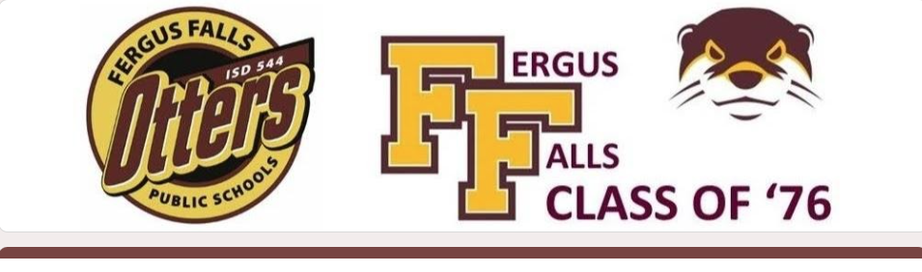
FFHS CLASS OF 1976 - 50th CLASS REUNION
WHEN: July 24-25, 2026
WHERE: Fergus Falls, MN
EMAIL: ffhsclassof76@gmail.com

It’s time to celebrate, reconnect, catch up with friends & classmates, listen to your favorite songs, and share memories from high school.
- - - - - - - - - - - - - - - - - - - - - - - - - - - - - - - - - - - - - - - - - - - - - - - - - - - - - - - - - - - - - -
Friday, July 24 - Casual Mixer at Mabel Murphy’s
- 6:00p to Close
- Food & beverages available for purchase.

Saturday, July 25 - Golfing @ Pebble Lake Golf Course in Fergus Falls
- Tee times start at 10:00am for 18 holes and at 12noon for 9 holes.
- To register, call directly to the PLGC Pro Shop (218-736-7404)
- Ask about reservations under ‘Class of 76'
- For more information & fees/pricing: https://www.playpebblelake.com
Saturday, July 25 – 50th Class Reunion @ VFW Post 612
- 5:00p - 6:00p: Social Hour (cash bar)
- 6:00p - 7:00p: Dinner
- 7:00p – Close: Casual Festivities w/Entertainment

- - - - - - - - - - - - - - - - - - - - - - - - - - - - - - - - - - - - - - - - - - - - - - - - - - - - - - - - - - - - - -
ONLINE REGISTRATION WILL BE OPEN UNTIL JULY 13th at:
https://forms.gle/z4TZ5qzqzc7DCRmJ9

OR

PLEASE FILL OUT THE BACK OF THIS FORM & MAIL IT W/YOUR PAYMENT TO:
FFHS Class of 1976, PO Box 98, Fergus Falls, MN 56537-0098

YOUR NAME: ___________________________________________________________
YOUR GUEST’S FULL NAME, if applicable: _________________________________
YOUR FULL MAILING ADDRESS: __________________________________________
YOUR EMAIL ADDRESS: ______________________________
YOUR CELL PHONE #: ______________________________

WHICH EVENTS YOU & YOUR GUEST PLAN TO ATTEND:

_____ I plan to attend both the Friday & Saturday events.

_____ I plan to attend only the Friday, July 24 event.

_____ I plan to attend only the Saturday, July 25 social & supper evening event.

_____ Sorry, I’m unable to attend either day.

PLEASE MAKE YOUR ENTRÉE CHOICES FOR SATURDAY EVENING:

_____ Baked Chicken w/Roasted Red Potatoes, California Vegetable Mix, Side Salad & Dinner Roll

_____ Roast Beef w/Roasted Red Potatoes, California Vegetable Mix, Side Salad & Dinner Roll

_____ Vegetarian Dinner Salad w/Choice of Italian, French or Blue Cheese Salad Dressings & Dinner Roll
-----------------------------------------------------------------------------------------------
FEE FOR SATURDAY EVENING EVENT: $29 per person
(please reach out if this presents a hardship)

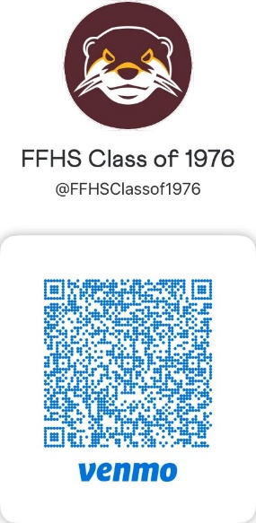

USE THIS VENMO URL LINK

or

MAKE CHECK OUT TO
‘FFHS Class of 1976’ AND MAIL TO:

FFHS Class of 1976
PO Box 98
Fergus Falls, MN 56537

